Moses’ Prayer (Adoration)
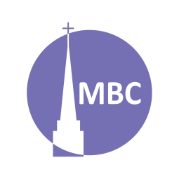
April 20

SERIES: Over April–May we’ll be studying 5 famous prayers of the Bible to learn of the 5 major types of prayers in the Bible.
Nehemiah 1:4–11 provides a helpful pattern for prayer that includes them all and is known as ACTS (adoration, confession, thanksgiving, supplication). Can you spot them?

CONTEXT: Adoration means to praise. To keep our focus on Him we should rightly praise God for who He is and His activity. Today we consider Moses’ prayer after the Crossing of the Red Sea.

FIRST, A.M. SERMON RECAP
- What was the theme of the sermon?
- What was/were the main point/s?
- What was the passage about?
- What stood out to you or provoked you to think?
- What were the key take-aways?

READ PASSAGE

QUESTIONS:
- Discuss: In your own words, what are prayers of adoration? Following Nehemiah 1, why is it useful to begin our prayers with praise?

- Can you think of any other prayers or verses from the Bible on this theme?

- What is the context of this prayer? How is this important for understanding it?

- Summarize this prayer in your own words.

- Is there anything in this prayer you do not understand?

- What does this prayer teach us about God?

- What does this prayer teach us about mankind?

- What do we see/what does this teach us about adoration?

  - Are there any secondary lessons?

- How has studying this prayer changed or deepened your view of prayers of adoration?

- Can you share a time when you prayed a prayer like this?

Spring Series:
Date | Prayer | Passage
April 20 | Adoration (Moses) | Ex 15:1–18
April 27 | Confession (David) | Ps 51
May 4 | Thanksgiving (Hannah) | 1 Sam 2:1–10
May 11 | Supplication (Hezekiah) | 2 Ki 19:15–19
May 18 | Intercession (Paul), a form of supplication | Eph 1:16–19, 3:14–19
May 25 | Members’ Meeting

