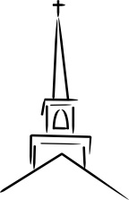
Cover to Cover: The 10 Commandments…

Exodus 22:33–23:33

Big Picture: https://www.youtube.com/watch?v=oNpTha80yyE

Context: Exodus 1–15 recount the story of the Exodus from Egypt, a story referred to again and again as a display of God’s grace and glory. Israel then journeyed through the Wilderness to Mt. Sinai where God gave His people specific instructs about how to live as His holy people. These are commonly called the 10 commandments, the Laws of Moses or the Mosaic Covenant. Following on from the 10 commandments, which are a sort of summary and representative of the entire Law of Moses, the LORD gave Moses many other specific laws.

Questions

The 10 Commandments used to be displayed in almost every church, taught and well known amongst. Today they can seldom be recalled. Why do you think that is?

The 10 Commandments may be split between Laws dealing with God and us and God and others. Which laws would fit into each category?
God and Us | God and Others
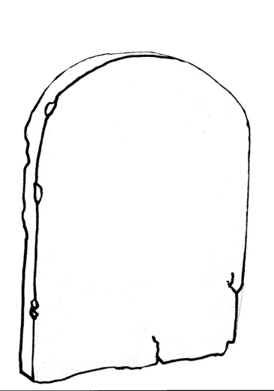
How are the 10 commandments mirrored in the Great Commandment (________)?

Though the Old Covenant was fulfilled in Christ, how are Christians to view the relationship between the Law and the Gospel?

Specific Questions:

Choose one law from each of the following 4 categories from today’s reading. Think about what it is saying and consider the wisdom of why God gave it (______). What relevance do you think it might have for today?

Laws of Restitution (which means

Laws of Social Justice

Laws about the Sabbath and Festivals

The Conquest of Canaan Promised

Choose a law from the (_____) may or may not apply?

BIG Questions to bear in mind:
- Where is this passage in the wider story of salvation history?
- In what ways does this passage point to Jesus? (Lk 24:27)

