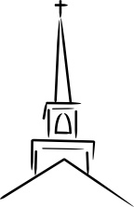
Cover to Cover: The Tabernacle and the Ark

Exodus 37:1–9

Big Picture: https://www.youtube.com/watch?v=oNpTha80yyE

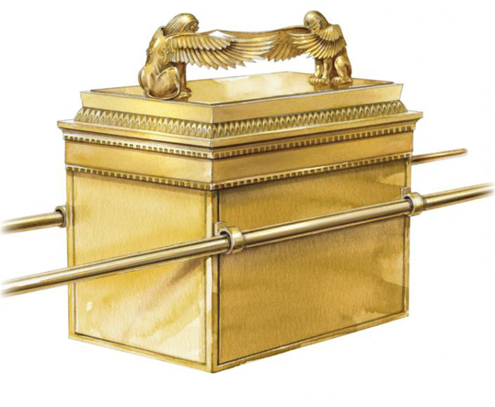
Context: Exodus 1–18 is the story of Israel’s dramatic rescue from slavery in Egypt. In the middle of Exodus God does two things: a) He lays out the Law of Moses and 2) He details the designs for His worship centre, the Tabernacle or Tent of Meeting. The Israelites entered into a covenant relationship with Him and He then took the relationship further by allowing His holy present to dwell amidst them (thus beginning to reverse what happened at the Fall, the loss of access to His presence). However, in Ch.32 Israel broke the covenant they just agreed to (hard hearts?). In His mercy, after renewing the covenant, God sets Moses to work building the Tabernacle. The Tabernacle was to have an outer court and a tent, itself with its own inner area called the “holy of holies.” There was also much holy hardware to be built, including the Ark. Today we’ll simply consider the Ark’s function in the Tabernacle (and later the Temple).

Questions

- Ark means chest, it was the Ark of the Covenant, the chest which carried the 10 Commandments (Nu 10:33; Dt 31:26; Heb 9:4).
- We’ve already heard about all of the details of the Tabernacle in chs. 25–31. Now it is being built. What strikes you about the details of these objects and their purposes?
- Think specifically of the description of the Ark (25:10–22, 37:1–9). What strikes you about its details and purpose?
- The “mercy seat” (or covering) was the lid of the Ark (also on this were the Cheribum). This is where blood was sprinkled to make atonement for the High Priest when he approached it. Above this rested the cloud of God’s presence. What do you think this picture symbolizes?
- The nations though the Ark was Israel’s god (1 Sam 4:6–7). In reality what did the Ark represent? (Nu 10:33; Deut 1:33; Ps 132:8)
- Who was to handle the Ark? Why? When was it moved?
- What was in the Ark? (Heb 9:4)
- What miracles did the Lord’s presence in the Ark create? (Jos 3:11, 6:4; 1 Sam 5:7, 6:1)
- Was it a magic charm or genie in a bottle? Can we manipulate God?
- Upon entering the Promised Land the Ark remained at Shiloh (1 Sam). After its capture by the Philistines it was brought to Kirjath-jearim (1 Sam 7:2). It was then brought into Jerusalem and eventually placed in the Temple and probably rediscovered by Josiah. Though stories like Indiana Jones abound, including the Ark being hidden on Mt. Nebo by Jeremiah or smuggled to Ethiopian by Ethiopian Jews (Queen of Sheba) or even stored in the Vatican, it is highly probable that the Ark was destroyed at the time of the Babylonian conquest.
- How does the Ark represent Jesus and the Gospel? (Heb 9)

