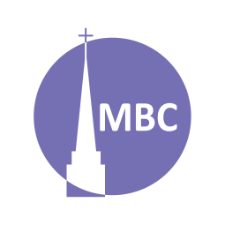

Acts: Iconium
May 10

INTRODUCTION: Acts: Jesus’ work, through the Apostles and disciples, by the Holy Spirit, to fulfil Acts 1:8. Being driven out of Antioch by unbelieving Jews, Paul and Barnabas travel down the Roman Road to Iconium, a major commercial and agricultural centre in southern Galatia.

KEY POINT: response, hostility, perseverance,

A.M. SERMON RECAP (Bill Barwick)
- What was the sermon about?
- What were the key points?
- Key takeaways…? Questions to keep considering?

P.M. SERMON RECAP (Doug Reider, Jonah 3)
- What was the sermon about?
- What were the key points?
- Key takeaways…? Questions to keep considering?

READ: Acts 14:1–7

QUESTIONS:
- V. 1a- How do Paul and Barnabas follow a similar approach? Does this repetition suggest anything for us today?
- V. 1b- What do you think Luke meant by “spoke in such a way?” Are there ways (as means) that can encourage or hinder faith in the Gospel?
- Just as in Antioch there are those who accept and those who reject. How does this universal pattern encourage and prepare us?
- V. 2a- Why is the term “unbelieving Jew” an incredible useful term when navigating the differences within the Old Testament and between the OT and the NT?
- Why are these Jews described as “unbelieving Jews” (e.g. what were Paul and Barnabas?)
- How did they stir and poison? Why will our enemies always resort to such under handed practices? (c.f. v. 5b)
- V. 3- “the word of His grace”- How is this a lovely description of the Gospel?
- V. 3- Amazingly, in the face of great opposition, they remain. Why?
- How does the Lord bolster their boldness? How does He do this today?
- Why does and why must we remember that the Gospel divides? (read and discuss Mt 10:34–39)
- Those who sided with the Jews did so because… and with the apostles…
- Fight or flight: When do you stay and “fight” and when is it time to be in flight? (e.g. when Paul escaped Damascus)
- They are forced from the larger Iconium to small cities and a region described as a “quiet backwater.” What does this teach us?

NEXT: May 17- Acts 14:8–18, Lystra

