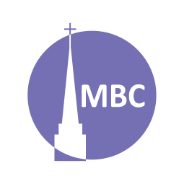

Acts: Lystra II
May 24

INTRODUCTION: Acts: Jesus’ work, through the Apostles and disciples, by the Holy Spirit, to fulfil Acts 1:8. In the midst of pointing the pagans of Lystra toward Christ… the unbelieving Jews show up.

KEY POINT: persistent opposition, strengthening, celebration

A.M. SERMON RECAP (Mt 4:19)
- What was the sermon about?
- What were the key points?
- Key takeaways…? Questions to keep considering?

P.M. SERMON RECAP (UK Recap)
- What did you learn about English Christian history?
- How is this an important part of our spiritual DNA?
- What is the Lord doing in the UK today? (livingstones)

READ: Acts 14:19–28

QUESTIONS:
- Have you ever encountered someone who wasn’t content to win the battle, they had to win the war? Why are true truth haters (vs. the merely ignorant) so militant? (stoning without a trial shows just how far they will go)
- What does it tell us that the Jews travelled 161km to continue their opposition to Christ tell us?
- Like the Triumphal Entry/Crucifixion, how are these crowds just as fickle?
- Why isn’t it a complement to be of fickle character? (Eph 4:14) Who does the Lord want us to be?
- 2 Cor 11:25- stoning was a very painful way to die yet Paul was spared. Not only was he spared (v. 20) what did he do? (Might this have been a miracle?)
- V. 20- were there any disciples? Why didn’t Paul flee like he had before?
- V. 21- Derbe hardly gets a mention, and with such a harvest!
- V. 21b–22 are remarkable verses. Not only are we called to make disciples but mature disciples. Discuss.
- Explore the 4 ways Paul did this?
  - Revisit
  - Strengthened souls
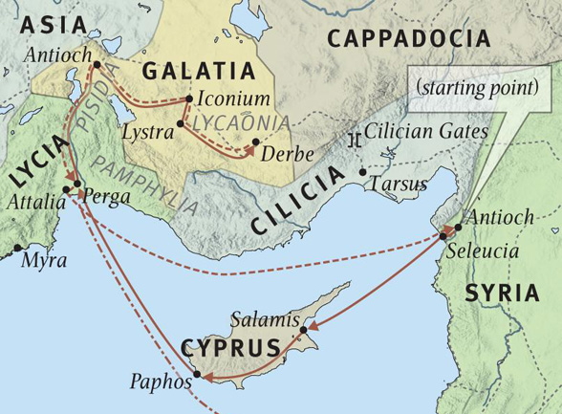
  - Encouraged them to continue in the faith
  - Many tribulations before glory
- Not only was Paul concerned for individuals (and organizing them into churches) but the body and so he appointed Elders. How is it amazing that Elders could already be found? Why did the young churches need Elders?
- V. 25- they finally were able to preach in Perga where illness had likely prevented them (But they didn’t go back to Cyprus?).
- How did Paul and Barnabas encourage their sending church upon their return? How does news of missions (local or…) encourage us?

*Thus ends the first missionary journey. We’ll take a pause in Acts before returning to the Jerusalem Council to consider the first letter Paul wrote to these churches in Galatia.

NEXT: May 31- No LG. Members’ Meeting

