Acts: Paul on Malta
Nov 22

INTRODUCTION: En route to Rome the ship Paul was on was driven off course by a storm. The Lord delivered Paul & co. by bringing them to an island. Here Paul unexpectedly witnesses before completing the journey to Rome.

KEY POINT: Providence, unexpected witness, miracles
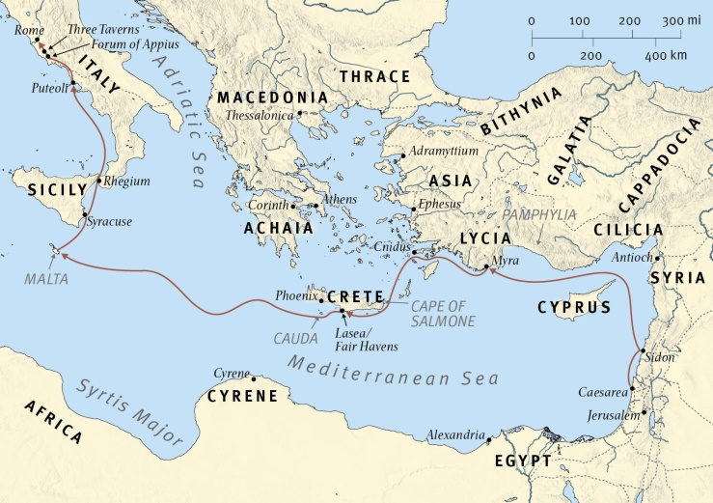

A.M. SERMON RECAP (Acts 27:1–12, Paul at Sea)
- Why did Luke devote so much space to Paul going to Rome and even this seemingly unimportant sea voyage?
- What lessons about witness amidst the journey of life do we find here?

P.M. SERMON RECAP (Acts 27:13–44, Paul in the Storm)
- What lessons about witness amidst the journey of life do we find here?

READ: Acts 28:1–11

QUESTIONS:
- Recount how the ship ended up at Malta, everyone alive. How had God providentially protected Paul, why?
- What Christians were with Paul?
- Trivia: What was/is Malta known for?
- Tradition still remembers this site as St. Paul’s Bay.
- Can you share a time when an unbelieving stranger show hospitality to you?
- V. 2- The Bible teaches totally depraved (not that we are as bad as we could be but that sin as totally effected body, soul and spirit, such that none seek God or can please Him). In light of this, how are we to understand the “unusual kindness” of the native people (i.e. non-Greeks)?
- What does it show that Paul was helping to gather sticks?
Witness #1
- V. 3- Pauls good act leads to a snake bite. Does anyone have a snake story?
- V. 4- Greco-Roman lore snakes would bite escapees of ships, probably a personification of the goddess Dike (justice/revenge)
- V. 5- We saw many sorts of miracles earlier in Acts. What is the miracle here? Purpose of miracles?
- V. 6- Like the fickle crowds of Lystra (Acts 14:11–19), what do the people do?
Witness #2
- Paul is still a prisoner but Julius’ favour continues…
- V. 7- Who was Publius? How does he too show hospitality?
- V. 8- What was wrong? Maltese fever was caused by Maltese goat milk and lasted up to four months). How long did it take Paul to cure him?
- What did this lead to?
- V. 10- How was Paul received? (passengers needed to bring meals)
Reflection
- How long was Paul on Malta? (v. 11)
- In God’s providence why did He bring them to Malta? Why does God take us off our planned path? Are we willing to say “thy will be done” for the sake of witness?
- Much like on the ship, it is inconceivable that Paul wasn’t actively sharing the Gospel. However, what doesn’t Luke tell us? Why?
- Tradition credits Paul with bringing Christianity to Malta, though evidence exists only from the 4th century.
- Pray 4 Malta (1.4% evangelical; illegal to speak on sexuality)

NEXT: Nov 22- Acts 28:30–31, Acts Wrap Up & Reflection

