Acts: Riot in Ephesus
Oct 4

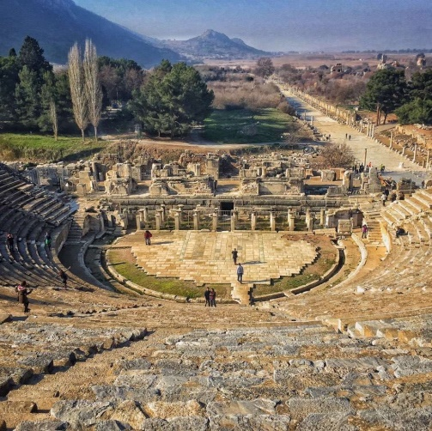
INTRODUCTION: In Ephesus Paul & Co.’s ministry was very effective. Luke has given 2 positive responses and 2 negative responses of witness; the latter having a silver lining. Many heard and responded to the Gospel (vv. 10 & 20). Today’s story illustrates this and provides a vindication similar to that in Corinth (Gallio, Acts 18:12–17).

KEY POINT: accusations, idolatry, vindication

A.M. SERMON RECAP (1 Cor 12, A Healthy Body for Mission)
- How do we join the universal body?
- Why do we identify with a local body?
- Why are we called to serve in the body?
- How does a healthy body help grow the body?

P.M. SERMON RECAP (Mt 3:7–17, God’s Children)
- What was the sermon about?
- What were the key points?
- Key takeaways…? Questions to keep considering?

READ: Acts 19:21–41

QUESTIONS:
Plans, vv. 21–22
- Paul had a plan to visit the churches and bring aid to the believers of Judea (Acts 24:17). He also had a BIG vision (though his name means “small”), which ultimately included Spain (Ro 15:24, 28). Why did he want to go to Rome and Spain?
- Why do you think he lingered in Ephesus a little bit longer?
Rome had no case against Christianity. Opposition was purely emotional and Christians had nothing real to fear from the authorities.
- Do you have a vision to become the best Christian you can be, to seek God’s will for your life, to tell others about Jesus, to see MBC fulfil the Great Commission?
Origin of Riot, vv. 23–27
- Demetrius, maybe the president of the silversmiths guild, had a cunning plan. What was his true motive (note this reason often appears in Acts)?
- How might Markdale bring an economic charge against us if our witness became this effective?
- How had preaching the Gospel harmed idolatry (especially the 2nd commandment)? How was it a clash between Jesus and Diana?
- Like Satan (the ‘angel of light’) how did Demetrius add patriotic and respectable motives as a cover-up? How is this often the way with liars?
Course of Riot, vv. 28–34
- Was there any real reason for the riot? How did it start? What does this teach us about mob rule or trends on social media?
- They went, probably along the main street, into the theatre, 500’ in diameter with a 25K seating capacity. Alexander was probably there to disassociate the synagogue from the church.
- Why was Paul prevented from speaking? Who, interestingly, came to his defence?
- How is this a caricature of the best paganism can offer against the truth?
End of Riot, 35–41
- The city clerk, its chief official, was a wise man. What were his key points that ended the madness? While not a guarantee, how does it pay to be reasonable? (Phil 4:5).
- Why do you think Luke chose to include this story of Roman allies (Asiarchs and Clerk) and legal vindication?
- In Canada today, what is the substance of most arguments made against Christians? Still today Christians are vindicated (here). How should this encourage us?

NEXT: Oct 11- Acts 21:1–16, Paul Goes to Jerusalem

