David’s Prayer (Confession)
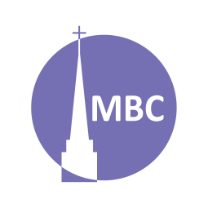
April 27

SERIES: Over April–May we’ll be studying 5 famous prayers of the Bible to learn of the 5 major types of prayers in the Bible.
Nehemiah 1:4–11 provides a helpful pattern for prayer that includes them all and is known as ACTS (adoration, confession, thanksgiving, supplication). Can you spot them?

CONTEXT: Confession means to acknowledge or be in agreement with. This can be positive (e.g. a Confession of Faith) or negative (confession of sin). In this latter sense confession means to agree with God’s standard that we have failed to measure up (Mt 5:48; Ro 3:23). The backdrop to today’s prayer of confession (Psalm 51) should give us all hope of forgiveness in the face of sin. The backdrop is the adultery, lies and murder found in 1 Sam 11–12.

FIRST, A.M. SERMON RECAP
- What was the theme of the sermon?
- What was/were the main point/s?
- What was the passage about?
- What stood out to you or provoked you to think?
- What were the key take-aways?

READ PASSAGE

QUESTIONS:
- Discuss: In your own words, what are prayers of confession? Following Nehemiah 1 (and the Lord’s Prayer), why is it useful to confess our sins as we approach God?

- Can you think of any other prayers or verses from the Bible on this theme?

- What is the context of this prayer? How is this important for understanding it?

- Summarize this prayer in your own words.

- Is there anything in this prayer you do not understand?

- What does this prayer teach us about God?

- What does this prayer teach us about mankind?

- What do we see/what does this teach us about confession?

  - Are there any secondary lessons?

- How has studying this prayer changed or deepened your view of prayers of confession?

- Can you share a time when you prayed a prayer like this?

Spring Series:
Date | Prayer | Passage
May 4 | Thanksgiving (Hannah) | 1 Sam 2:1–10
May 11 | Supplication (Hezekiah) | 2 Ki 19:15–19
May 18 | Intercession (Paul), a form of supplication | Eph 1:16–19, 3:14–19
May 25 | Members’ Meeting

