The Armour of God 3
July 13

INTRODUCTION: We’re in a battle but our Captain has bestowed us with all the weapons needed for our warfare. Relying on Him and by sticking together we can stand against the Prince of Darkness and advance the Kingdom!

FIRST, A.M. SERMON RECAP (Phil 4:12)
- Define ‘content’ in your own words.
- What signs show that the world is not content?
- Why is the world never content?
- How is Christ the key to contentedness?
- On a scale of 1 to 10 how content are you? Why aren’t you content?
- How can Christians grow in contentedness?

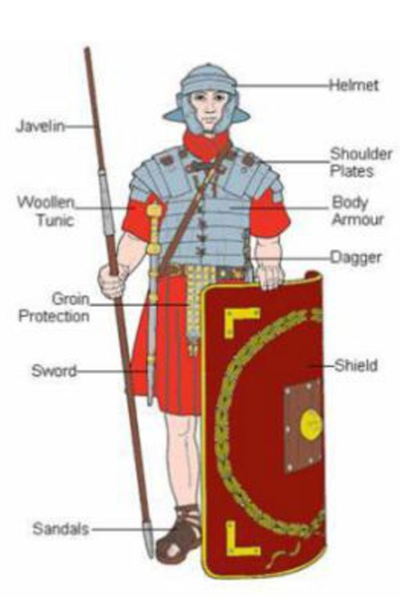
RE-READ PASSAGE: Eph 6:10–20 (focus= vv. 17–20)

QUESTIONS:
- Recap last week’s study in your own words.
- In painting the analogy of armour Paul is drawing upon OT stories and passages along with the readily available image of the Roman army of his day (see opposite).
- Complete the following chart. For each item consider its natural purpose (what body part it protects or what it was used for) and then using the descriptors in each verse (e.g. “belt of truth”) consider its spiritual meaning:
Item | Body Part Protected/Purpose | Spiritual Meaning
Helmet, v. 17a
Sword, v. 17b
Standard or signals (Prayer), v. 18

Vv. 18–20
- Prayer is not only a lifeline in battle but the ultimate spiritual weapon. How is prayer spiritual and an effective spiritual weapon?
- How many times is “all” used in this passage? What does this tell us?
- When should we pray?
- How should we pray? (Ro 8:26)
- For whom should we pray?
- To what end should we pray?
- Fighting can be a tiring ordeal. What refreshments does the Lord give His soldiers? What ultimate hope do we have to keep fighting (Rev 20:10)?

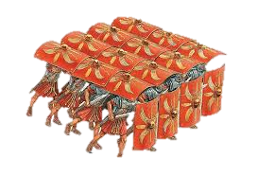
Next Week: Introducing the Sermon on the Mount, our study for the remainder of the year (Mt 5–7).

