The Armour of God 2
July 6

INTRODUCTION: Christians are part of a cosmic battle between the King and a rebellious prince. For this battle Christians must rely upon the Lord and the armour that He has given His church. We must equip ourselves to fight this battle together—no lone rangers allowed.

FIRST, A.M. SERMON RECAP (1 Tim 4:8)
- Should Christians be concerned about fitness and health?
- What excess in fitness existed in Paul’s day and ours?
- Why is godliness more important than fitness?
- What is godliness?
- How do I become godly?
- How do I grow in godliness?
- Why should I pursue godliness?

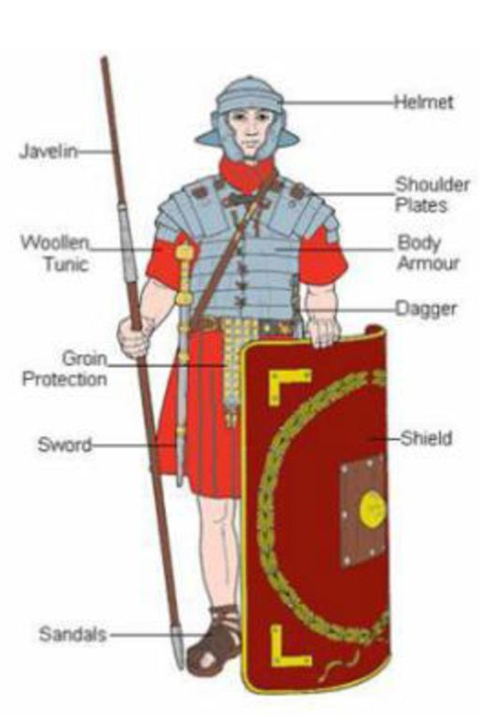
RE-READ PASSAGE: Eph 6:10–20 (focus= vv. 14–16)

QUESTIONS:
- Recap last week’s study in your own words.
- In painting the analogy of armour Paul is drawing upon OT stories and passages along with the readily available image of the Roman army of his day (see opposite).
- Is the picture of the soldiers/army offensive, defensive, or both?
- Complete the following chart. For each item consider its natural purpose (what body part it protects or what it was used for) and then using the descriptors in each verse (e.g. “belt of truth”) consider its spiritual meaning:
Item | Body Part Protected/Purpose | Spiritual Meaning
Belt, v. 14a
Breastplate, v. 14b
Shoes, v. 15
Shield, v. 16
- As important as each item is, why must we “put on the whole armour of God.” (v. 11).
- How do we take up these items?

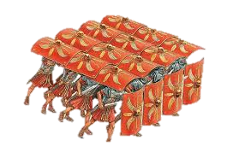
Next Week: The Armour of God, Eph 6:17–20

