Hezekiah’s Prayer (Supplication)
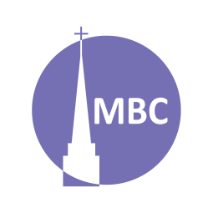
May 11

SERIES: Over April–May we’ll be studying 5 famous prayers of the Bible to learn of the 5 major types of prayers in the Bible.
Nehemiah 1:4–11 provides a helpful pattern for prayer that includes them all and is known as ACTS (adoration, confession, thanksgiving, supplication). Can you spot them?

CONTEXT: Supplication, or to supplicate (sup-from below; plicate- to please); a humble request (a petition) before a [great] king. In this prayer we have a righteous king of Israel, Hezekiah, besieged by the mighty Assyrian Empire. Terrified, rather than turning away, Hezekiah turns to the LORD for help.

FIRST, A.M. SERMON RECAP
- What was the theme of the sermon?
- What was/were the main point/s?
- What was the passage about?
- What stood out to you or provoked you to think?
- What were the key take-aways?

READ PASSAGE: 2 Ki 19:15–19 (c.f. 2 Chr 32; Isa 37)

QUESTIONS:
- Discuss: In your own words, what are prayers of supplication? Following Nehemiah 1, why do we bring our supplications before God? Why is it helpful to defer these sorts of prayers (as in Nehemiah 1)? When do they rise to the fore?

- Can you think of any other prayers or verses from the Bible on this theme?

- What is the context of this prayer? How is this important for understanding it?

- Summarize this prayer in your own words.

- Is there anything in this prayer you do not understand?

- What does this prayer teach us about God?

- What does this prayer teach us about mankind?

- What do we see/what does this teach us about supplication?

  - Are there any secondary lessons?

- How has studying this prayer changed or deepened your view of prayers of supplication?

- Can you share a time when you prayed a prayer like this?

Spring Series:
Date | Prayer | Passage
May 18 | Intercession (Paul), a form of supplication | Eph 1:16–19, 3:14–19
May 25 | Members’ Meeting
June 1 | Series: Fruit of the Spirit

