Paul’s Prayer (Intercession)
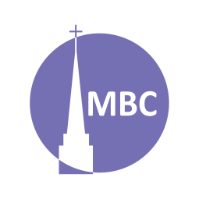
May 18

SERIES: Over April–May we’ll be studying 5 famous prayers of the Bible to learn of the 5 major types of prayers in the Bible.
Nehemiah 1:4–11 provides a helpful pattern for prayer that includes them all and is known as ACTS (adoration, confession, thanksgiving, supplication). Can you spot them?

CONTEXT: Intercession (litt. to go between) means to intercede on behalf of someone in prayer (think Jesus the High Priest, our intercessor). Rather than a reactive letter, this letter proactively seeks to establish the Ephesians in the faith (c.f. Acts 19). Here Paul shares passionately of his prayer for the Ephesians. It is a prayer of thanksgiving but also one of intercession (“remembering you in my prayers”). We too are called to pray for others.

FIRST, A.M. SERMON RECAP
- What was the theme of the sermon?
- What was/were the main point/s?
- What was the passage about?
- What stood out to you or provoked you to think?
- What were the key take-aways?

READ PASSAGE: Eph 1:16–19, 3:14–19

QUESTIONS:
- Discuss: In your own words, what are prayers of intercession (a form of supplication)? Following Nehemiah 1, why do we bring supplications for others before God?

- Can you think of any other prayers or verses from the Bible on this theme?

- What is the context of this prayer? How is this important for understanding it?

- Summarize this prayer in your own words.

- Is there anything in this prayer you do not understand?

- What does this prayer teach us about God?

- What does this prayer teach us about mankind?

- What do we see/what does this teach us about intercession?

  - Are there any secondary lessons?

- How has studying this prayer changed or deepened your view of prayers of intercession?

- Can you share a time when you prayed a prayer like this?

- Having concluded 5 weeks looking at 5 different types of prayers through 5 famous prayers:
  - What has the Lord taught you?
  - What questions do you still have?
  - Where can you grow in your prayer life?
Spring Series:
Date | Prayer | Passage
May 25 | Members’ Meeting
June 1 | Series: Fruit of the Spirit

