Hannah’s Prayer (Thanksgiving)
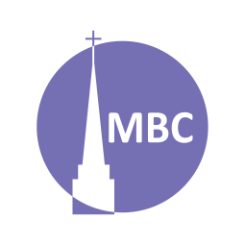
May 4

SERIES: Over April–May we’ll be studying 5 famous prayers of the Bible to learn of the 5 major types of prayers in the Bible.
Nehemiah 1:4–11 provides a helpful pattern for prayer that includes them all and is known as ACTS (adoration, confession, thanksgiving, supplication). Can you spot them?

CONTEXT: Thanksgiving means to rejoice over an experience of God’s grace, to be thankful for something you didn’t deserve. Hannah, who had been barren, had great reason to rejoice over Samuel’s birth! In an age when great stigma was attached to childlessness, Hannah cried out to the Lord (1 Sam 1). The Lord heard her cry. Her son would replace Eli’s worthless leadership to provide a mighty prophet for Israel.

FIRST, A.M. SERMON RECAP
- What was the theme of the sermon?
- What was/were the main point/s?
- What was the passage about?
- What stood out to you or provoked you to think?
- What were the key take-aways?

READ PASSAGE: 1 Sam 2:1–10

QUESTIONS:
- Discuss: In your own words, what are prayers of thanksgiving? Following Nehemiah 1, why is it useful to bring our thanks before God?

- Can you think of any other prayers or verses from the Bible on this theme?

- What is the context of this prayer? How is this important for understanding it?

- Summarize this prayer in your own words.

- Is there anything in this prayer you do not understand?

- What does this prayer teach us about God?

- What does this prayer teach us about mankind?

- What do we see/what does this teach us about thanksgiving?

  - Are there any secondary lessons?

- How has studying this prayer changed or deepened your view of prayers of thanksgiving?

- Can you share a time when you prayed a prayer like this?

Spring Series:
Date | Prayer | Passage
May 11 | Supplication (Hezekiah) | 2 Ki 19:15–19
May 18 | Intercession (Paul), a form of supplication | Eph 1:16–19, 3:14–19
May 25 | Members’ Meeting

